**Product: Social Stock Analyzer**

**Team:** Gurpinder Singh, Nout Reusken, Mihika Marathe, Ojas Upadhye, Qiuxia Tang

**Sprint Completion Date:** 02/08/22

**Revision Number:** 4

**Revision Date:** 2/28/22

**Goal:**

Users can access their account and create a basic portfolio. They also should be able to navigate through the website. The user should also be able to access the basic financial information.

**Task Listing:**

* As a user, I would like an intuitive flow between the different functionalities with easy access to each separate feature. (3)
  + Set up navigation / react routing allowing flow from log in to homepage. (2 hours) - Mihika
* As a user, I should be able to look up a stock and view its price trend and basic financial information so that I can make a decision about investment. (5)
  + Connect to alpaca api to fetch stock data (3 hours) - Gurpinder
  + Display the data for the stock that’s fetched (3 hours) - Gurpinder
* As a user I should be able to add a searched stock to my portfolio/watch list If I want so that I can monitor the progress.(9)
  + Create an option to add a stock to the portfolio when it’s searched for. (F&B) (4 hours) - Ojas
  + Set up portfolio page (Dashboard) (6 hours) - Nout
* As a user, I should be able to change my personal information including my password, username, and name. (5)
  + Populate the settings page with options to change the name/email/password. (3 hours) - Mihika

**Spikes:**

* As a I should be able to configure the info I see on a particular stock based on the type of investor I am so that I only need to see information relevant to me.
  + Research on tailoring information toward different types of investors. (5 hours) - Qiuxia

**Team Roles:**

Gurpinder Singh: Developer/Product Owner

Nout Reusken: Developer

Mihika Marathe: Scrum Master

Ojas Upadhye: Developer

Qiuxia Tang: Developer

**Initial Task Assignments**

Listed above

**Initial Burnup Chart:**

*live version on Jira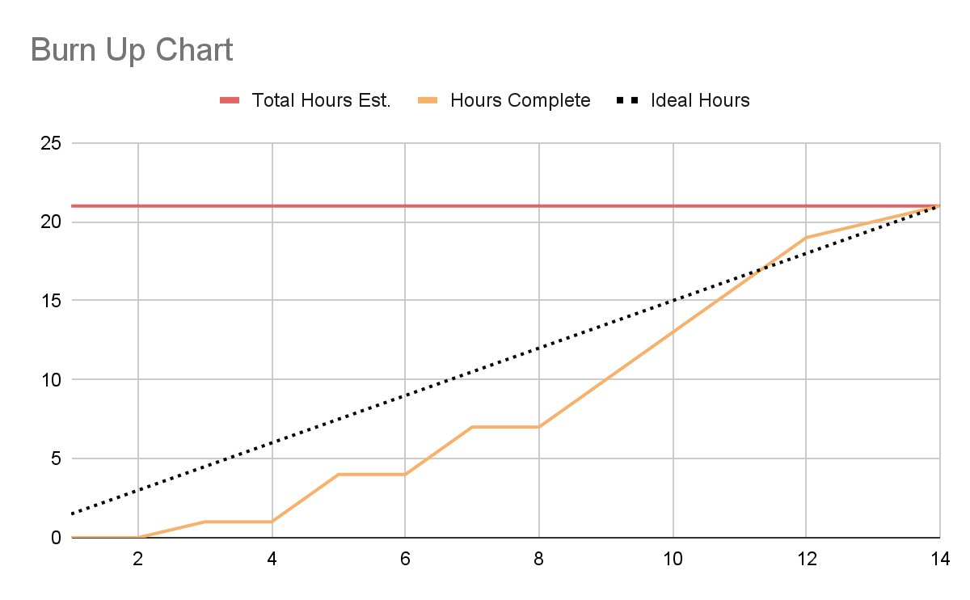

**Initial Scrum Board:** (task board, separate columns for tasks not started, tasks in progress, tasks completed)

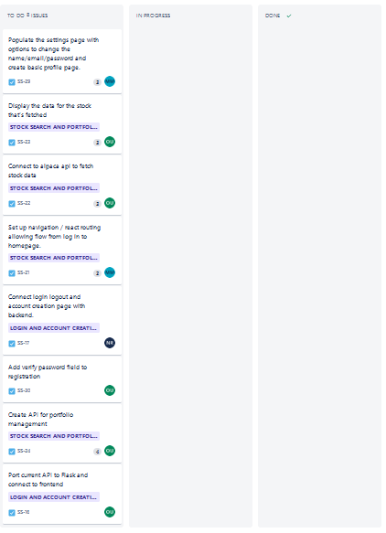

**Scrum Times:** (3 times that the team meets every week, including one with the TA)

1. Friday 4:30-5:15 PM PST, meeting with TA

<https://zoom.us/j/8572731488?pwd=VTI2WTRIbEhqU3dtL3NNMGZTWldBZz09>

1. Tuesday 5:00 PM PST
2. Sunday 4:00 PM PST